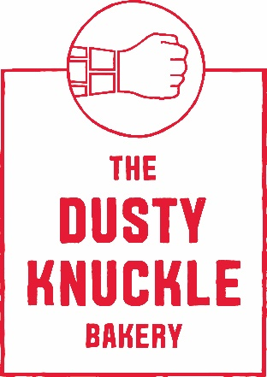

Job title BAKER

Location: Dalston. Abbot st, E8 3DP
Contract: 40 hours
Start date: ASAP
Salary: £23,000 - £28,000 per annum depending on experience

The Dusty Knuckle Bakery is a purpose driven business which operates busy cafes and restaurants, serving very high quality food and drinks whilst also distributing bread and pastry to other businesses. Whilst we consider our products at TDK to be some of the best in London, we are about much more than just baking.
TDK runs a youth training programme. We provide work-based mentorship/support, training, and employment opportunities to at risk youth, including those with offending histories. We believe in equipping trainees with the confidence, skills, personal accountability, and support network to develop productive, functional lives.
We have worked tirelessly since 2014 to grow the business from a fledgling start-up in a 40 ft shipping container into a profit-for-purpose food venture with strong brand recognition and a loyal following. We now employ 80 staff and are developing training routes specifically designed and reserved for at-risk young people. Our social impact program is embedded within the bakery, kitchen, and café operations.
TDK is at an exciting time in its growth. We expanded our production HQ and opened a second London site in 2021; we now aim to expand to other sites over the coming years alongside the expansion and refinement of our training program for young people.

The role
This is an excellent opportunity to join our hard working baking team and to have the opportunity to make some of the best bread and pastries around. We are a small team of passionate bakers, making products we care deeply about. You will be part of a successful, positive team, where staff welfare is prioritised. There will also be opportunities to support our young trainees through mentoring and shadowing on shift.
At TDK , we offer:
- Paid training days
- Additional day’s holiday for every year worked
- Regular inhouse massages for staff
- Free staff food, coffee, bread and pastries every day
- Cycle to Work scheme
- Employee support and specialist third party wellbeing service
- Regular appraisals to develop person-specific career goals
- Day off on your birthday!
- 4 day week rota patterns
- No over night shifts

You will: (include any non-negotiable must-haves for the particular role, BE SPECIFIC along with the basics that we want from people, see listed below)

- Be methodical and diligent
- Have a resilient character and a strong personal drive
- Have a commitment to making delicious things whilst being a team player and being orgainsed.
- Going above and beyond on shift to create the best products possible.
- Be committed to TDK values of Nurture, kindness, honesty and aiming high aim

To apply for this position please send your CV to daisy@thedustyknuckle.com alongside a cover letter explaining, based on the skills required for the job, why you are suitable for the role and why you want to work at The Dusty Knuckle.

