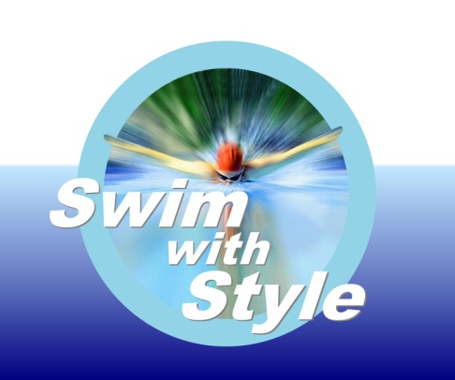

JOB DESCRIPTION and PERSON SPECIFICATION

SWIMMING INSTRUCTOR

Responsible to: |  | Hours of Work:
Status of position: | Casual | Salary Range:

- INTRODUCTION

Swim with Style Ltd is an independent swim school, committed to the highest standards of swimming teaching. Its vision is to be the best independent swim school in the county.

The swim school is an Ltd company and is registered with the STA. The swim school is owned and run by Glynis Sheppard and currently has around 40 members of staff. The staffs meet every term and there are ad hoc meetings to oversee the running of the swim school.

- MAIN PURPOSE OF ROLE
The Swimming Instructor will be called upon to undertake adhoc duties to provide swimming instruction to a range of abilities and ages.

- LEVEL OF POSITION

The Post holder will be directly responsible to the ****************who is responsible for day-to-day Line Management to include appraisal, training and development and health and safety.

- DUTIES AND RESPONSIBILITIES

The duties and responsibilities below are illustrative duties. The position holder will be expected to become involved in a range of work, on occasions that may not be illustrated below.

Main Responsibilities:

- To teach swimmers of all abilities
- To help build confidence of the nervous swimmer
- To support the other instructors
- To work as a team
- To take over a group if the occasion arises
- To liaise with parents as and when necessary
- To work in the water as an assistant if required
- To mark attendance each week on booking system
- To update progress each week on booking system

Specialist Responsibilities

  - To instruct the swimmer with empathy
  - To encourage water confidence
  - To teach to STA standards

Contacts

In all contacts the successful applicant will be required to present a good image of Swim with Style as well as maintain constructive relationships. The successful applicant will liaise with the following:

- TERMS AND CONDITIONS

- Hours: The position is part-time and casual and you will agree your working hours with your manager every half term you may be called upon to work as and when required. The swim school programme is term time only but pool will be operational throughout the year so if wanted you can also include working hours during the school holidays.

- Other: You will be expected to have an up-to-date DBS Disclosure, which is required every 3 years,

PERSON SPECIFICATION
SWIMMING INSTRUCTOR

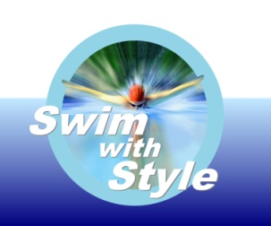

ATTRIBUTES | ESSENTIAL CRITERIA | DESIRABLE CRITERIA
Qualifications | - STA AWARD  - SAT LIFESAVING  - SAFEGUARDING | - STA CERTIFICATE  - POOL LIFEGUARD
Work Experience | - To have a minimum of 6 months teaching experience | - To have a knowledge of the STA learn to swim programme
Specialist Knowledge | - To have a good understanding of the correct technique for teaching the 4 main strokes and aquatic skills  - To be able to perform all strokes and skills necessary
Job Related/Personal Skills | - To empathise with the swimmer  - To be able to communicate with all levels of swimmers | - To be able to make learning fun
Other/ Special Working Conditions | - Non-smoking environment

