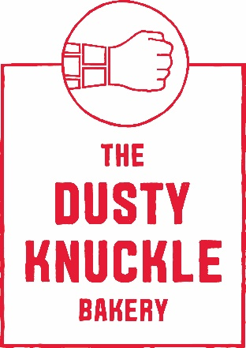

Job title Sous Chef
Location: Haringey, Green Lanes N4
Contract: 40 hours
Start date: ASAP
Salary: £28k
Application closing date:

The Dusty Knuckle Bakery is a purpose driven business which operates busy cafes and restaurants, serving very high quality food and drinks whilst also distributing bread and pastry to other businesses. Whilst we consider our products at TDK to be some of the best in London, we are about much more than just baking and cooking.
TDK runs a youth training programme. We provide work-based mentorship/support, training, and employment opportunities to at risk youth, including those with offending histories. We believe in equipping trainees with the confidence, skills, personal accountability, and support network to develop productive, functional lives.
We have worked tirelessly since 2014 to grow the business from a fledgling start-up in a 40 ft shipping container into a profit-for-purpose food venture with strong brand recognition and a loyal following. We now employ 80 staff and are developing training routes specifically designed and reserved for at-risk young people. Our social impact program is embedded within the bakery, kitchen, and café operations.
TDK is at an exciting time in its growth. We expanded our production HQ and opened a second London site in 2021; we now aim to expand to other sites over the coming years alongside the expansion and refinement of our training program for young people.

The Role
This is an excellent opportunity to join our latest site in Haringey. Our café/restaurant is open seven days a week, where we cook a simple but exceptional menu. Open for additional evening service, Thursday to Saturday, where we fire up our oven, serving pizzas alongside other delicious dishes and sides. You will be cooking within a successful, positive team, where staff welfare and training is prioritised. There will also be opportunities to support our young trainees through mentoring and shadowing on shift. The role as Sous Chef is a supportive role to the head chef. You will be running shifts, ordering and be fully responsible for all kitchen operations in the absence of the head chef.

At TDK , we offer:
- Paid training days
- Additional day’s holiday for every year worked
- Regular inhouse massages for staff
- Free staff food, coffee, bread and pastries every day
- Cycle to Work scheme
- Employee support and specialist third party wellbeing service
- Regular appraisals to develop person-specific career goals
- Day off on your birthday!
- Access to use of our campervan if over 25 Years old.

You will:
- Be methodical, exceptionally organised with good attention to detail
- Have a resilient character and a strong personal drive and be prepared to take on feedback
- Be exceptionally hard working with a clear aptitude for leading a team
- Have a commitment to good seasonal produce with strong kitchen skills
- Have a good understanding of how service functions successfully in a professional kitchen
- Be committed to TDK values of Nurture, kindness, honesty and aiming high

To apply for this position please send your CV to harry@thedustyknuckle.com alongside a cover letter explaining, based on the skills required for the job, why you are suitable for the role and why you want to work at The Dusty Knuckle.

