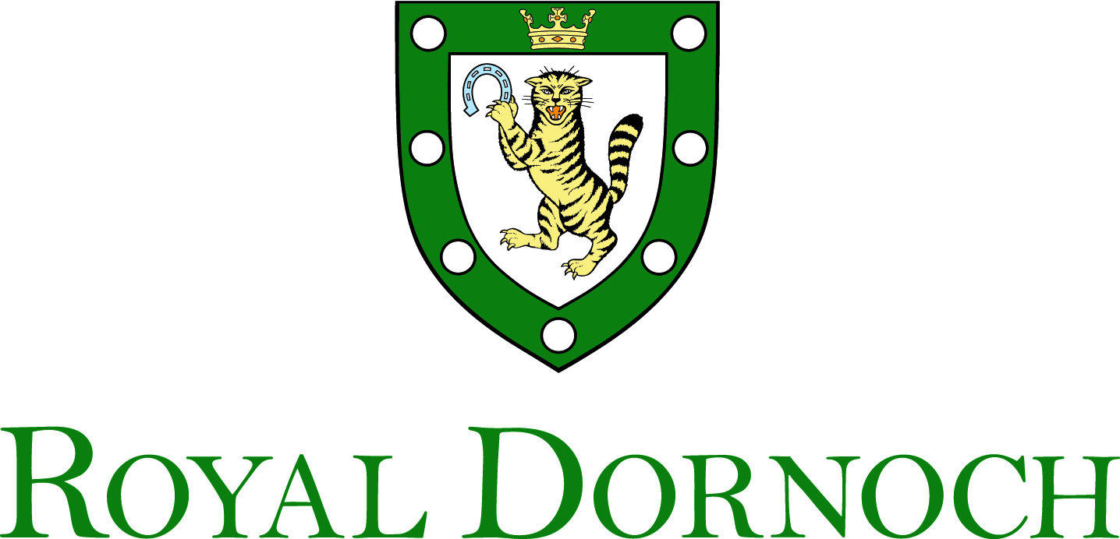

Chef de Partie

25,058 to 28,236 based on an average of 37.5 hours per week

What do you get from being part of the team at Royal Dornoch?

- A full time permanent job that guarantees your income all year round
- Annual pay rise to keep your salary in line with the economy
- We don’t do breakfast or late dinners so no early mornings or late nights
- Free membership of Royal Dornoch Golf Club which, amongst other benefits, gives you access to our Championship Course that is ranked 4th in the world.
- A pension scheme that club contributes the equivalent of over 5% of your salary too
- A share of tips and gratuities
- Free uniform so that always feel part of the team
- Free food while on duty
- Free staff social events
- 6 weeks holiday each year
- If you live outwith the area then you can access subsidised accommodation

What do we want in return?

As a member of the kitchen team you will provide food for our members, their guests and our visitors. We pride ourselves on the quality of what the club provides and the satisfaction it gives to our customers.

- Help with the preparation and service of menu items, functions and staff meals
- Managing the performance of the station that you have been allocated to ensure high levels of productivity and low wastage.
- Suggest and participate in discussions on dishes and menus.
- Accept deliveries, ensure stock is controlled & rotated and ensure minimum kitchen wastage and to communicate when stock is running low
- Follow the cleaning schedules for the kitchen, and to clean the areas and sections as directed
- Working with all of the catering management team to ensure the kitchen is operating effectively and efficiently.
- Enforcing kitchen, personal and food hygiene policies within the kitchen

Full training will be given both on the job and at the local further education college for those who wish to enhance their qualifications and their careers.

