Details

Job Title Programme Planner

Reporting to Operations Director

Depot Podington, Northamptonshire

THE ROLE

You will be responsible for compiling the company-wide delivery programmes for all business streams and offices into a single programme. The emphasis will be to deliver programme efficiencies, resources, materials, and recruitment profiles and produce monthly reports at operational and board levels.

A typical week might involve

- Managing Primavera P6/Microsoft project planner software
- Supporting the delivery of a projects running UK wide
- Collaborating with a variety of different stakeholders for the delivery of all projects
- Developing and maintain a programme strategy
- Implementing programme organisation and reporting structures
- Developing and maintaining an effective resource, materials, and cost plan
- Supporting the Operations team in managing their budgets, productivity, costs, project risks, issues, project scope and project change control in line with objectives and targets
- Supporting the team to deliver initiatives within the organisation to continually improve the operations performance, the quality of delivery, and our focus on the Health and Safety practices in the environment we work in

As a rapidly growing business, no two days are ever the same so what you do will vary. The nature of our business and the pace we move at also means that priorities do change, and you will need to be comfortable with this.

apply if You are

- Details orientated
- Experienced in constructing project programmes and interchanging data between Prima Vera P6, and Microsoft Project software packages
- Proficient in Windows operating systems
- Have experience with Primavera P6 / MS project
- Committed to great Customer Service
- Experienced in communicating with internal and external stakeholders
- Strong at planning and organising
- A capable problem solver and decision-maker
- An effective communicator both written and verbal
- A team player
Why us?

We are a growing business, and we are doing big and exciting things. We are looking for likeminded people who want to grow with us and be part of our journey and in return we offer a collaborative working environment where we encourage and support continuous improvement and career development.

Our values underpin how we work and act and are crucial to our ongoing success.
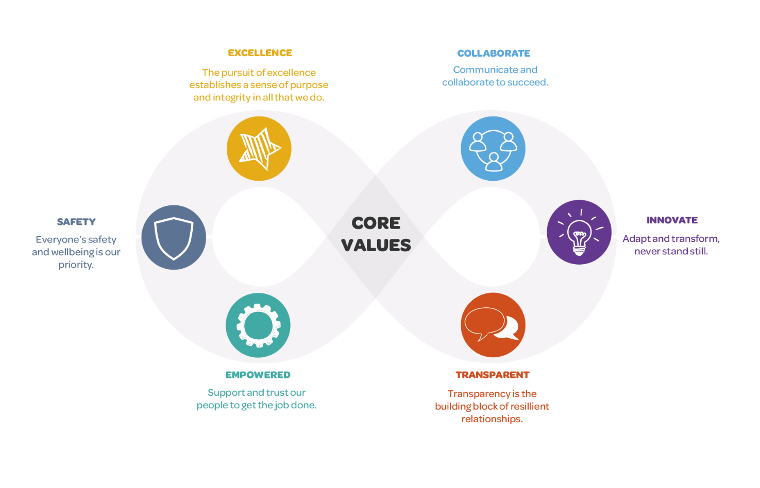

We want applicants from all backgrounds and walks of life. We aim to be an equal opportunities employer and want to create a diverse workforce and inclusive environment free of discrimination and harassment.
We are committed to equal opportunities throughout employment, including remuneration, recruitment, training, and promotion of staff. We are dedicated to candidates being treated equally and assessed in accordance with their skills to perform the role we are recruiting for, and that no candidate or employee receives less favourable treatment or is unlawfully discriminated against on grounds of age, disability, gender, marital status, pregnancy, race, religion, belief, sexual orientation, or any other protected characteristic. If there is anything you need to participate fully in the interview process, we want to help so please include it in your application.

