Details

Job Title Operative

Reporting to Regional Operations Manager

Depot Podington, Northamptonshire

THE ROLE

You will be carrying out general civils work alongside a team of operatives and be at the forefront of onsite delivery. You will be required to work safely and to a high quality. Showing a high level of understanding of working upon high-speed roads, traffic signs, highway lighting and/or highway technology, associated civils works.

The Podington, depot will be your “base” but the role will require you to be based on site for works carried out.

A typical week might involve

- General civils works including Working at height, Lantern installation, Sign erection, Duct laying, Reinstatement, Cabling
- Excavation by mechanical means and/or lifting operations via a HIAB or grab wagon
- Operating heavy plant or wagons
- Trail holes/hand excavation if required
- Building of cabinet/feeder pillar sites
- Construction of chambers to highway & utility specifications
- Identifying risks and problems on site with the ability to provide pro-active solution’s
As a rapidly growing business, no two days are ever the same so what you do will vary. The nature of our business and the pace we move at also means that priorities do change, and you will need to be comfortable with this.

apply if You are

- Able to undertake manual work including manual trenching cable laying etc
- Comfortable working night shifts and away from home if required
- Committed to all installations being completed to the correct standard, delivered on time and to budget
- Prepared to positively participate in all training relevant to your role
- Committed to a high level of health and safety as per company policies/procedures
- Committed to ensuring all works are completed as per MSF HSEQ policies and procedure and to reporting any HSEQ issues to supervisor and via Eyes and Ears App
- Experienced as a Lead Operative
- Able to work as part of a team with good communication skills
- HERS registered / a CSCS Card Holder

Our operations staff are to work on the strategic roads network and above all must be able to always work safely. Working as part of a team our road workers present good communication skills and follow instructions and comply with site rules and MSF SHEQ policies.

Why us?

We are a growing business, and we are doing big and exciting things. We are looking for likeminded people who want to grow with us and be part of our journey and in return we offer a collaborative working environment where we encourage and support continuous improvement and career development.

Our values underpin how we work and act and are crucial to our ongoing success.
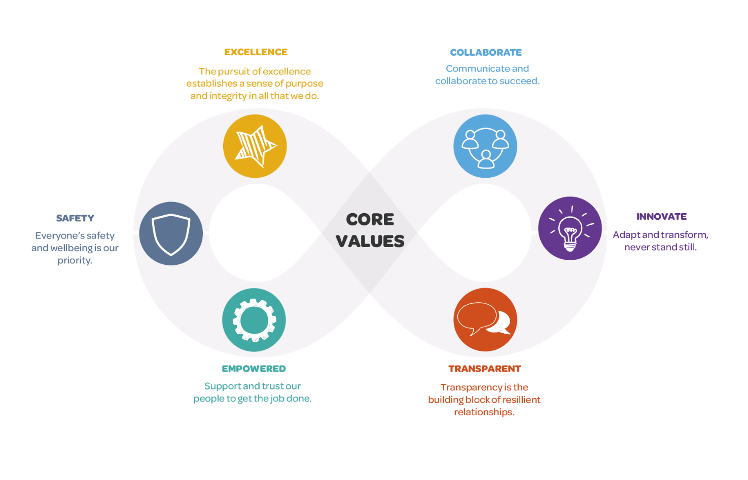

We want applicants from all backgrounds and walks of life. We aim to be an equal opportunities employer and want to create a diverse workforce and inclusive environment free of discrimination and harassment.
We are committed to equal opportunities throughout employment, including remuneration, recruitment, training, and promotion of staff. We are dedicated to candidates being treated equally and assessed in accordance with their skills to perform the role we are recruiting for, and that no candidate or employee receives less favourable treatment or is unlawfully discriminated against on grounds of age, disability, gender, marital status, pregnancy, race, religion, belief, sexual orientation, or any other protected characteristic. If there is anything you need to participate fully in the interview process, we want to help so please include it in your application.

