Details

Job Title Estimator – Trainee

Reporting to Pre-Construction Manager

Depot Podington, Northamptonshire

THE ROLE

You will learn how to determine the total cost of a construction project before work commences. You will become involved in projects in the early stages covering everything from materials, labour, equipment hire, transport costs and everything in between. You will be fundamental to the business winning projects and achieving turnover and profitability.

A typical week might involve

- Understanding client needs
- Learning how to prepare tenders for projects
- Understand the process to support management and monitoring of key tenders
- Completion of tender review for all estimates
- Preparing and submitting quotations for work
- Helping with bids for new contracts and supporting buying activities
- Gathering quotes from sub-contractors and suppliers
- Completion of tender handovers for contracts awarded
- Researching materials, equipment, and labour costs.
- Review and provide proposal for improved Purchasing
- Prepare construction budgets & labour profiles prior to tender handover

As a rapidly growing business, no two days are ever the same so what you do will vary. The nature of our business and the pace we move at also means that priorities do change, and you will need to be comfortable with this.

apply if You are

- Proficient in Microsoft Office
- An Analytical thinker
- Interested in the detail
- Self-motivated
- An excellent communicator both written and verbal
- Keen to learn and take part in necessary training to succeed in the role

Why us?

We are a growing business, and we are doing big and exciting things. We are looking for likeminded people who want to grow with us and be part of our journey and in return we offer a collaborative working environment where we encourage and support continuous improvement and career development.

Our values underpin how we work and act and are crucial to our ongoing success.
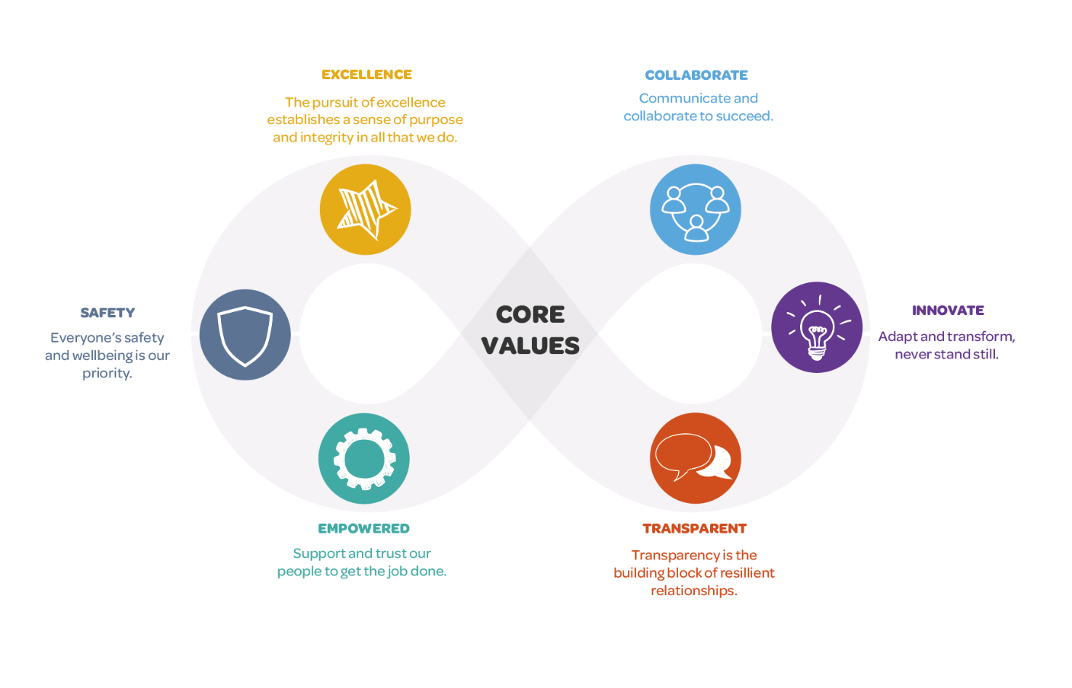

We want applicants from all backgrounds and walks of life. We aim to be an equal opportunities employer and want to create a diverse workforce and inclusive environment free of discrimination and harassment.
We are committed to equal opportunities throughout employment, including remuneration, recruitment, training, and promotion of staff. We are dedicated to candidates being treated equally and assessed in accordance with their skills to perform the role we are recruiting for, and that no candidate or employee receives less favourable treatment or is unlawfully discriminated against on grounds of age, disability, gender, marital status, pregnancy, race, religion, belief, sexual orientation, or any other protected characteristic. If there is anything you need to participate fully in the interview process, we want to help so please include it in your application.

