Details

Job Title Estimator Co-ordinator

Reporting to Pre-Construction Manager

Depot Podington, Northamptonshire

THE ROLE

To provide support and assistance to the estimating department to ensure the smooth running of the department and to support our estimators in their roles and workload. There is a lot of moving parts so multi-tasking, initiative, and communication skills will all be essential.

A typical week might involve

- Logging each new tender onto our system
- Saving the works information correctly into the standard file structure
- Recognising if a tender is a re-price of a quotation which would have been previously submitted, then logging it appropriately
- Checking the information supplied with the tender request is adequate for the Estimators to provide the best and most cost-effective quotation
- Issuing a thank email confirming receipt and the submission date
- Learning and following the tendering process
- Obtain quotations from subcontractors, material suppliers, and for any specialist plant
- Supporting with quality submissions
- Assisting with tenders and the hand over process if required
- Gathering Production rates from previous tenders to check tendered outputs

As a rapidly growing business, no two days are ever the same so what you do will vary. The nature of our business and the pace we move at also means that priorities do change, and you will need to be comfortable with this.

apply if You are

- Proficient in Microsoft Office
- An Analytical thinker
- Interested in the detail
- Self-motivated
- An excellent communicator both written and verbal
- Keen to learn and take part in necessary training to progress in the role
- Team player

Why us?

We are a growing business, and we are doing big and exciting things. We are looking for likeminded people who want to grow with us and be part of our journey and in return we offer a collaborative working environment where we encourage and support continuous improvement and career development.

Our values underpin how we work and act and are crucial to our ongoing success.
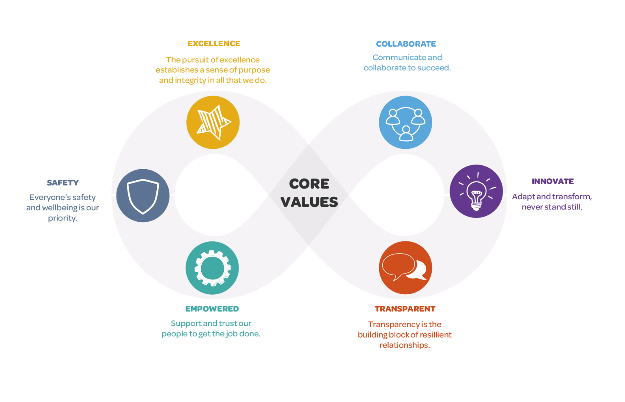

We want applicants from all backgrounds and walks of life. We aim to be an equal opportunities employer and want to create a diverse workforce and inclusive environment free of discrimination and harassment.
We are committed to equal opportunities throughout employment, including remuneration, recruitment, training, and promotion of staff. We are dedicated to candidates being treated equally and assessed in accordance with their skills to perform the role we are recruiting for, and that no candidate or employee receives less favourable treatment or is unlawfully discriminated against on grounds of age, disability, gender, marital status, pregnancy, race, religion, belief, sexual orientation, or any other protected characteristic. If there is anything you need to participate fully in the interview process, we want to help so please include it in your application.

