Details

Job Title Buyer

Reporting to Pre-Construction Manager

Depot Podington, Northamptonshire

THE ROLE

You will play a vital role in the company, supporting the contracts team by taking responsible for buying materials and equipment needed for the successful completion of schemes on budget and to agreed timeframes. You will build relationships with suppliers and peers to ensure you fully understand the brief and are well equipped to make the best decisions when buying materials to secure the best prices and lead times.

A typical week might involve

- Attending tender handover meetings and reviewing the handover packages including material quotations, data sheets and tenders to ensure you have all the relevant information
- Assisting the Contracts Managers with the material approval process to ensure a smooth handover
- Building strong relationships with suppliers to get the best prices available and keep costs at a minimum
- Organising deliveries of materials and equipment with the relevant Contracts Manager to confirm locations, timeframes, and budgets
- Updating the material order schedule to assist the Contracts Managers with scheme delivery and programme
- Reviewing the supplier delivery schedules to group deliveries together and increase the efficiency of lead times and delivery costs
- Highlighting any concerns or delays over material lead times to the relevant Contracts Managers and Senior Management where necessary
- Raising Technical Queries alongside approval of materials

As a rapidly growing business, no two days are ever the same so what you do will vary. The nature of our business and the pace we move at also means that priorities do change, and you will need to be comfortable with this.

apply if You are

- A strong negotiator
- Have solid relationship building skills
- Proficient in Microsoft Office
- Well organised, and confident dealing with multiple deadlines
- A good team player and strong communicator

Why us?

We are a growing business, and we are doing big and exciting things. We are looking for likeminded people who want to grow with us and be part of our journey and in return we offer a collaborative working environment where we encourage and support continuous improvement and career development.

Our values underpin how we work and act and are crucial to our ongoing success.
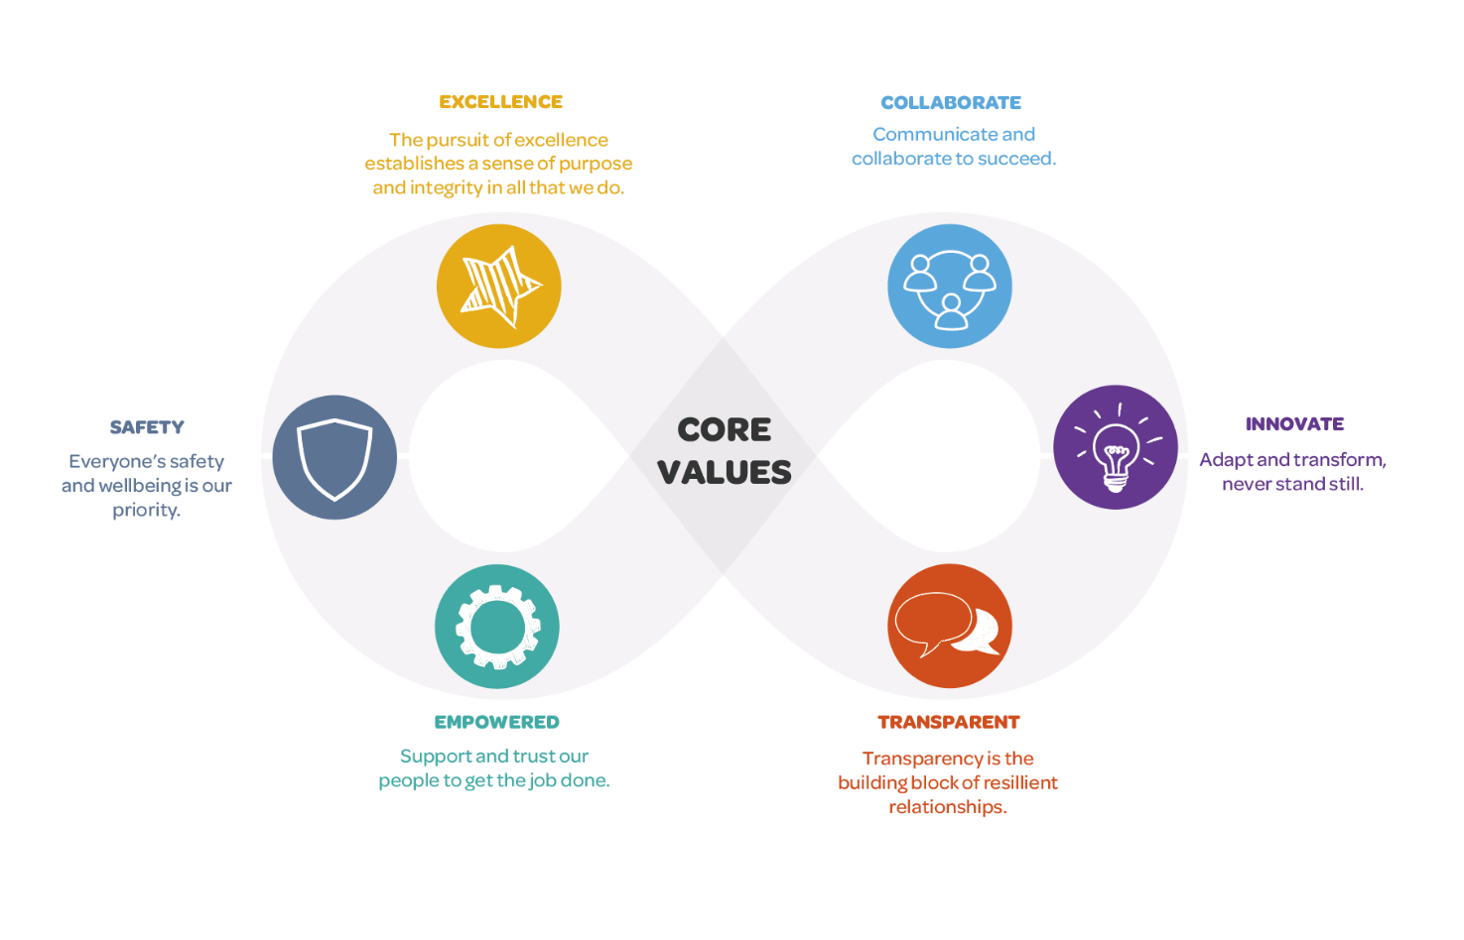

We want applicants from all backgrounds and walks of life. We aim to be an equal opportunities employer and want to create a diverse workforce and inclusive environment free of discrimination and harassment.
We are committed to equal opportunities throughout employment, including remuneration, recruitment, training, and promotion of staff. We are dedicated to candidates being treated equally and assessed in accordance with their skills to perform the role we are recruiting for, and that no candidate or employee receives less favourable treatment or is unlawfully discriminated against on grounds of age, disability, gender, marital status, pregnancy, race, religion, belief, sexual orientation, or any other protected characteristic. If there is anything you need to participate fully in the interview process, we want to help so please include it in your application.

