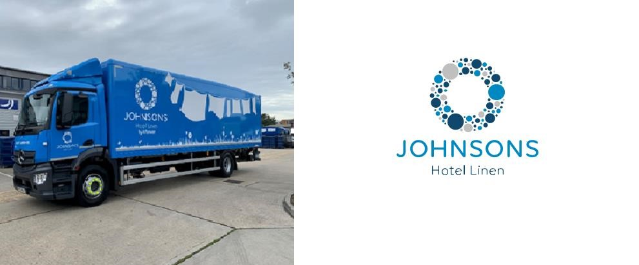
CREATING OPPORTUNITIES & CAREERS
We have permanent job opportunities at all of our commercial laundry sites. We can also accommodate those who want a role for a fixed period of time to help them into the work environment (e.g., 6-12 month fixed term contracts). There are opportunities at all of our sites in production, transport and loading.
Our Cardiff production team for example operates 5 ironers, 2 automatic towel folders and a fully automatic quality control scanning system 24/7. Working alongside our 4 shift managers, all training will be provided on commencement of the job, with the opportunity for ongoing training for all positions.
Variety of shift patterns on both day shift and night shift.

About Us
Johnsons Hotel Linen, part of Johnsons Service Group is one of the UK’s largest high volume laundry and linen hire companies.
Every week we deliver over 9 million items of linen, supplying over 75,000 hotel bedrooms across England, Wales and Scotland, making us one of the leading suppliers providing and washing bed linen to the hotel industry in the UK. With 9 major commercial laundries we offer nationwide coverage sharing best customer practice and enabling our customers to be serviced wherever their hotels are located. Including our state of the art factory newly opened in Leeds.

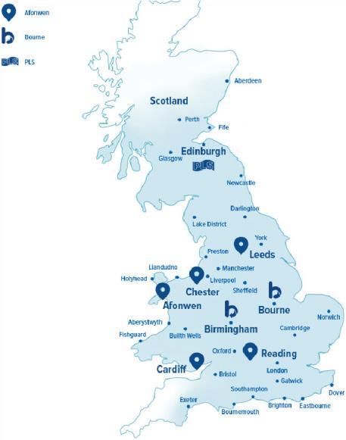
Our Laundry Site Locations:
Cardiff
Pwllheli
Reading
Chester
Leeds
Birmingham
Bourne, Lincoln
Edinburgh

There are opportunities for progression to:
- Production team leader, supervisor
- Loader
- Van driver, HGV driver
- We also offer LGV Apprenticeships and Textile Care Operative Apprenticeships to kick start your career with Johnsons
- Pay rates at above National Living Wage
- SAYE scheme, EAP, free onsite parking at most sites, Free Life Assurance, Pension and opportunity for future progression

For more information please visit: jsg.com

Contact: rebeccamorgan@jsg.com

